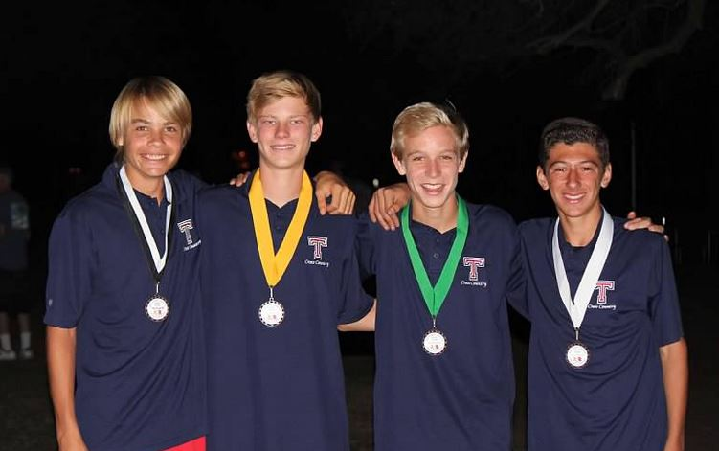

TESORO BOYS GAMEDAY TEAM POLOS
_____________ MEN’S ADULT SMALL ______WOMENS ADULT SMALL
_____________ MEN’S ADULT MEDIUM ______WOMENS ADULT MEDIUM
_____________ MEN’S ADULT LARGE ______WOMENS ADULT LARGE
_____________ MEN’S ADULT XL ______WOMENS ADULT XL
_____________ MEN’S ADULT XXL ______WOMENS ADULT XXL

_________ X $25 = $__________

ATHLETE NAME______________________________________________________

MAKE CHECKS PAYABLE TO TESORO XC

